FCH5 -

Functionality
This functions allows you to link manually issued checks with the payment documents. In order to keep the use and management of manually created checks separate from those created automatically, a separate number range should be reserved for them.

Scenario
The automatic payment run was made without having the relevant check lot in the system. You have to enter the check details in the check register manually.

Requirements
You need to manually post a payment document before you can use this transaction.

Menu Path | Accounting → Financial Accounting → Accounts Payable → Environment → Check information → Create → FCH5 - Manual checks
Transaction Code | FCH5
1. Double click on FCH5 - Manual checks.

Create Check Information

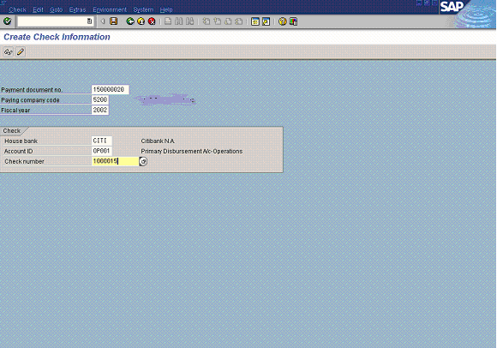

2. Update the following fields:

Field Name | Field Description | Values
Payment document number | Number of payment document you want to create a check for | Example: 150000020
Paying company code | The company code which processes the payment transactions | Example: 5200
Fiscal year | Fiscal year number | Example: 2002
House bank | Identification number for the house bank to which the transaction corresponds | Enter value in House bank.  Example: CITI
Account ID | Code identifying the account to which the General Ledger account corresponds | Enter value in Account ID.  Example: OP001
Check number | The unique check number per company code, bank, and account number | Example: 1000015

3. Click Enter Button to confirm your entries.

Create Check Information

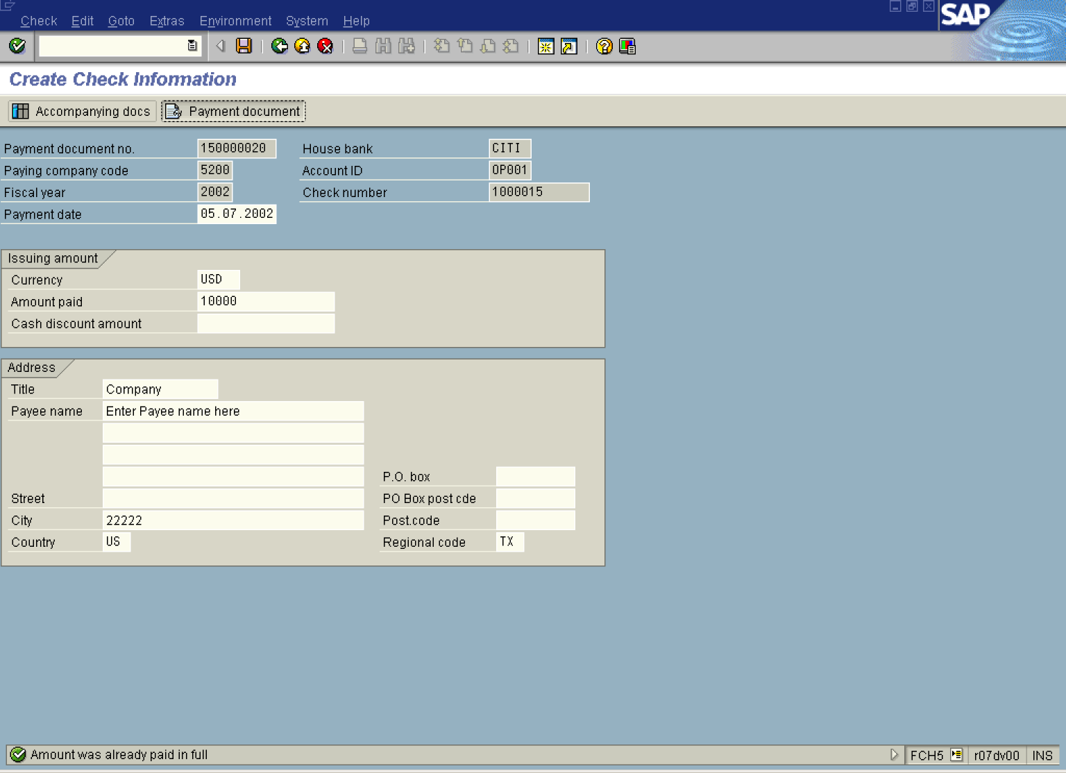

4. Update the following fields:

Field Name | Field Description | Values
Amount paid | Amount for which the check is written | Example: 10000
Payee name | Name of the vendor being paid | Example: Enter Payee name here

5. You can display, if you want, the payment document details. Click Payment document Button .

Display Document: Overview

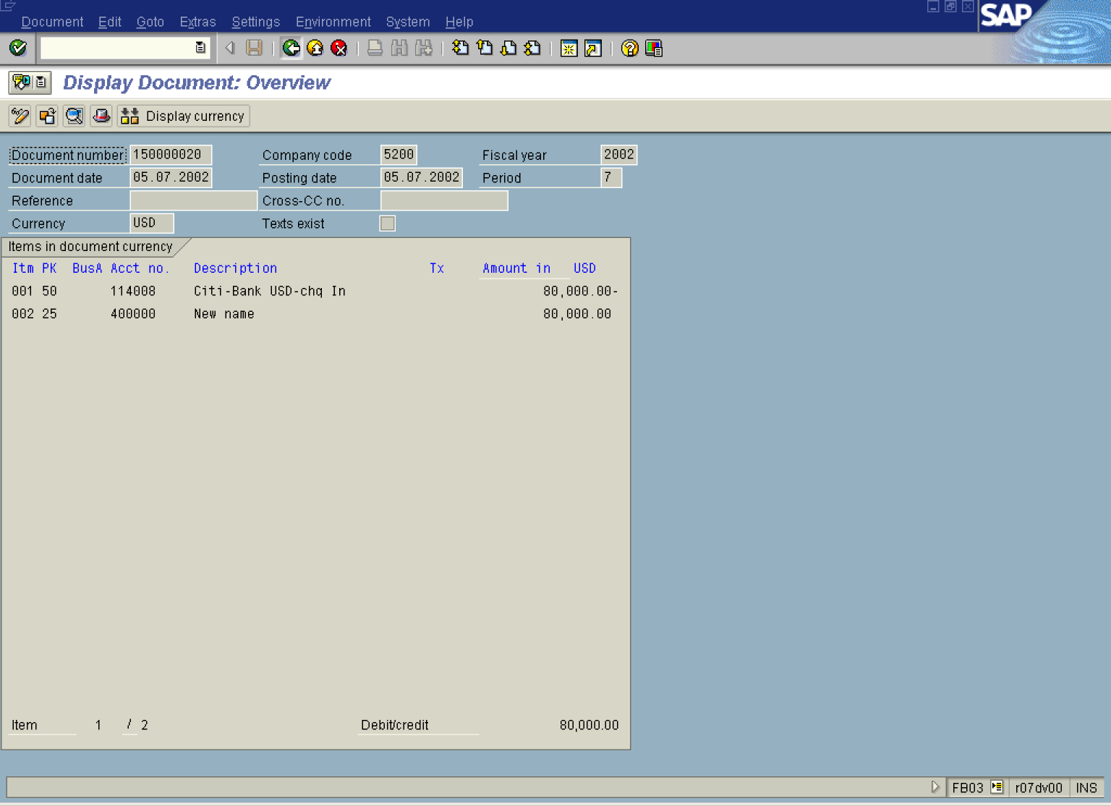

6. Click Back Button .

Create Check Information

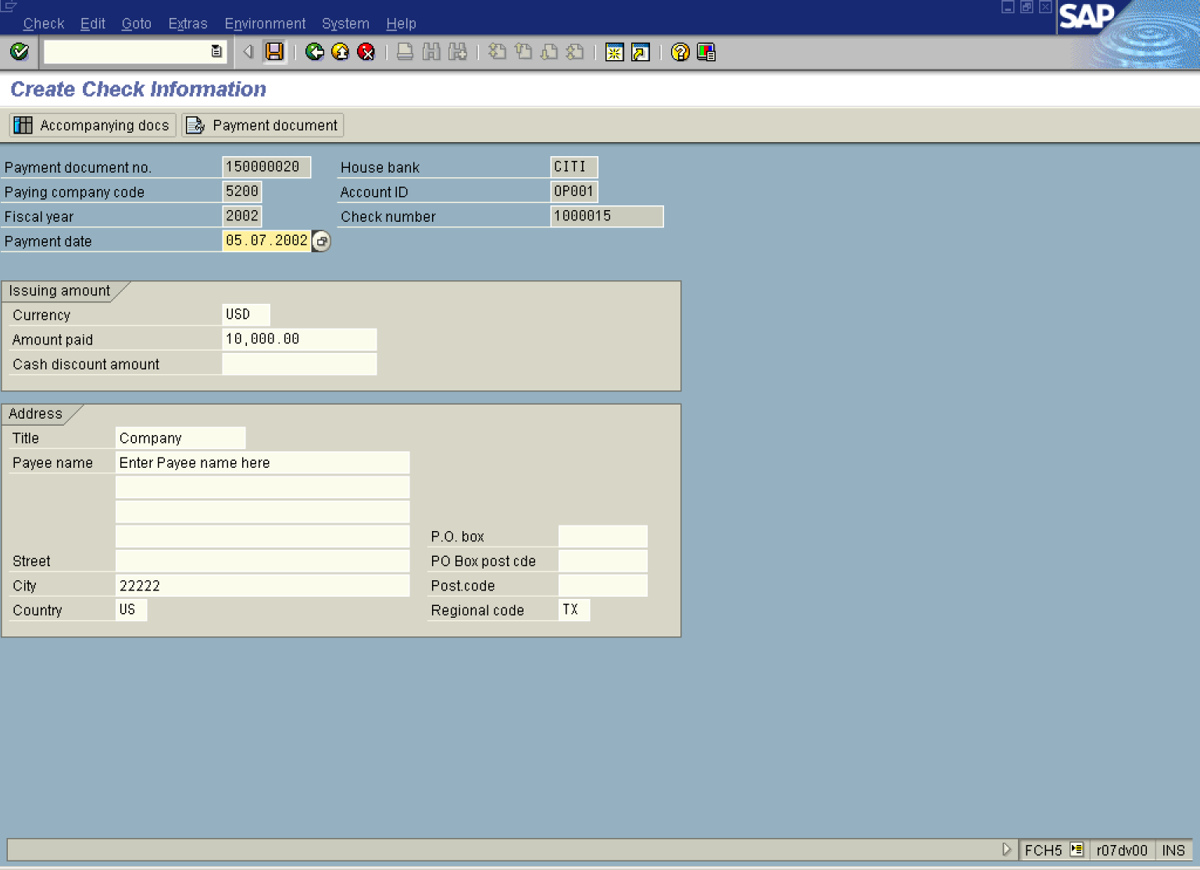

7. Click Save Button. to create the check data for the payment document.

8. The message bar displays “Check 5200 CITI OP001 1500000015 created manually”.

